**Task 1 and 2 (Installation of Visual Studio and its configuration):**

1. Creating a Project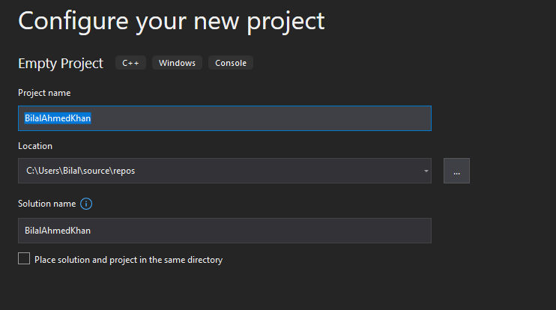
2. Masm Checkbox

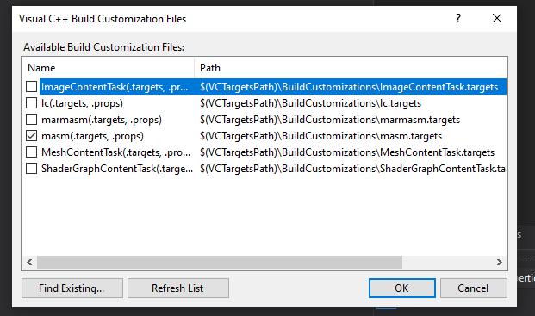

1. Naming the file

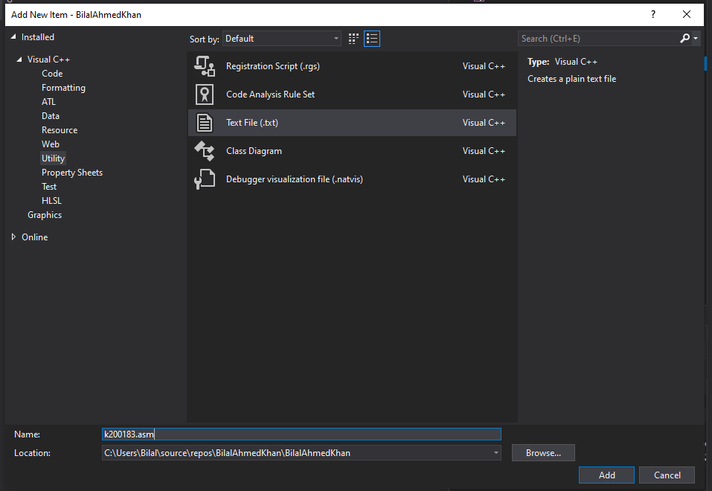

1. Including Paths



1. Including Additional Library Directories

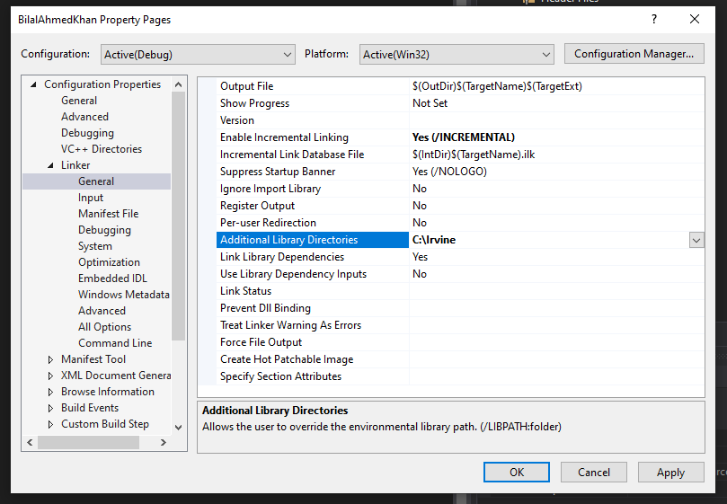

**Task 3 (Running a test program and changing some values):**

**Running a test program**

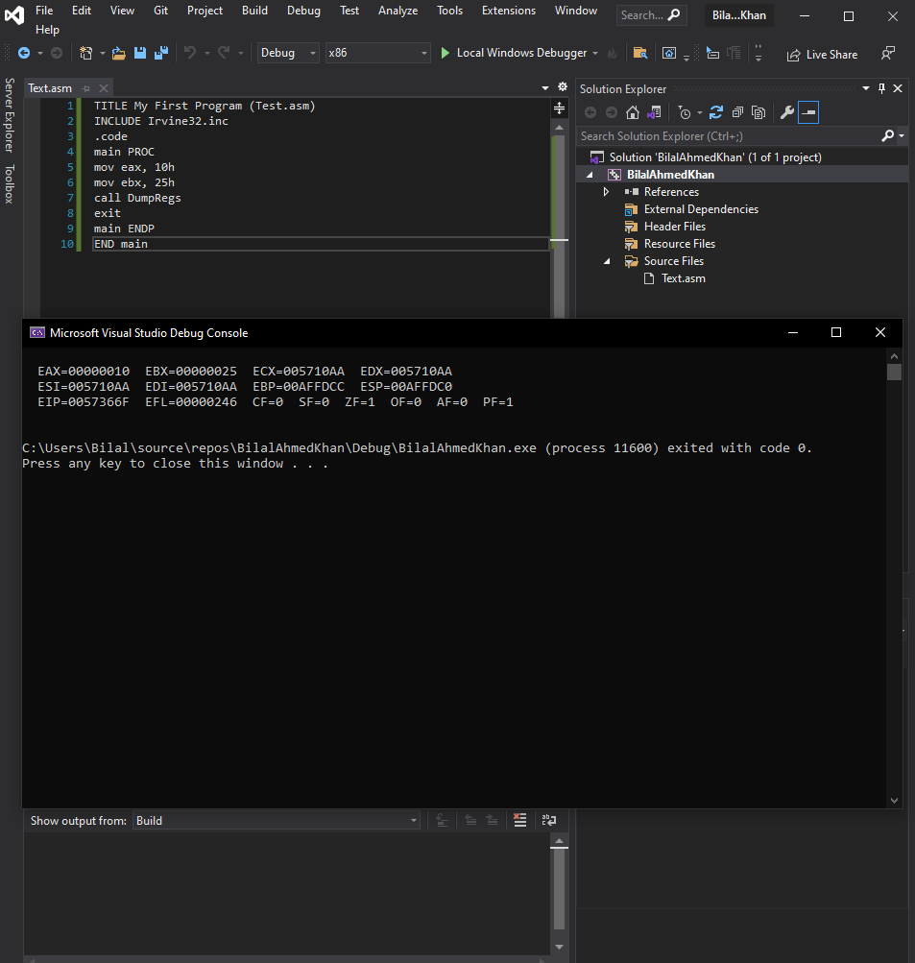

**Changing the value of EAX in line 6 to 8500h**

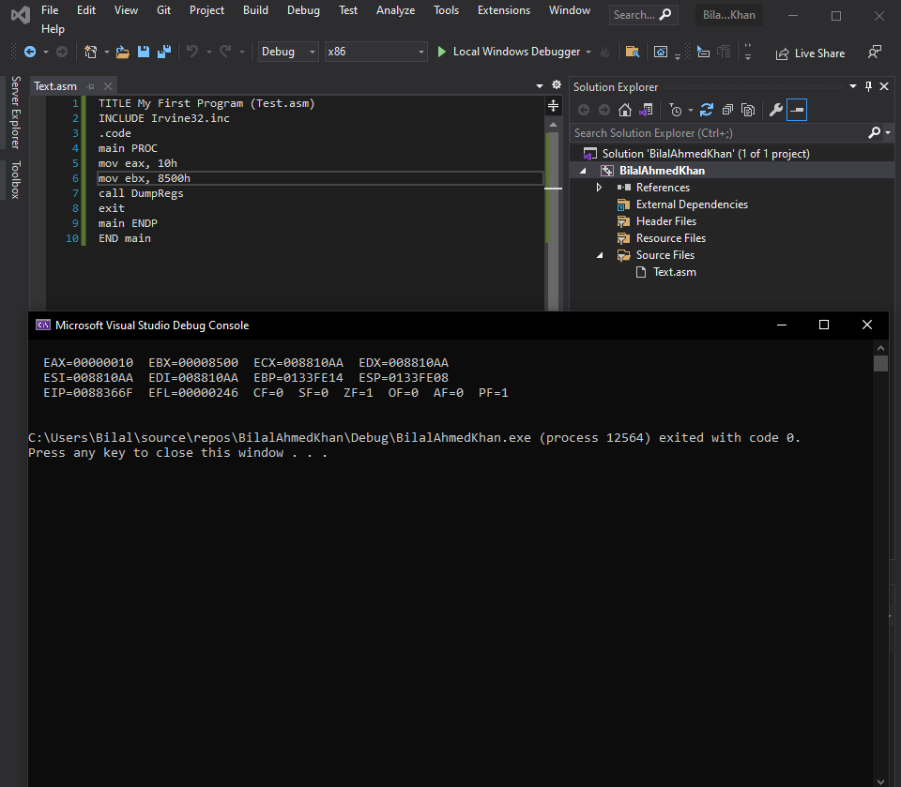

**Task 04 (Debugging)**

**Line 06**

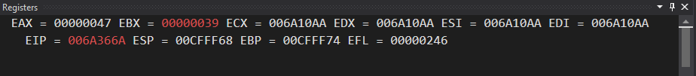

**Line 07**

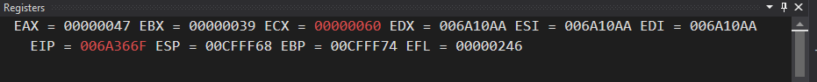

**Line 08**



**Line 09**

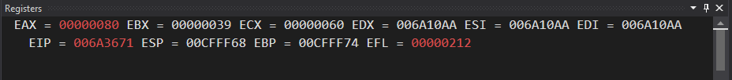

**Line 10**

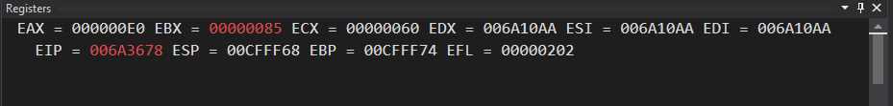

**Line 11**

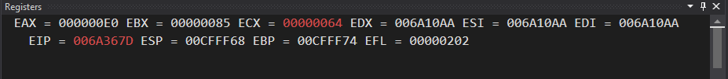

**Line 12**

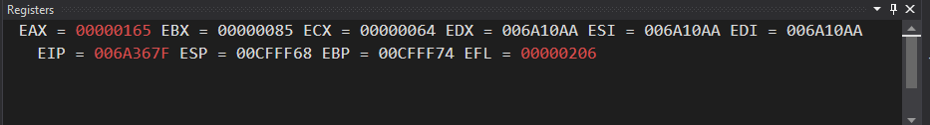

**Line 13**

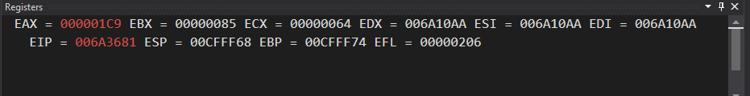

**Line 14**

